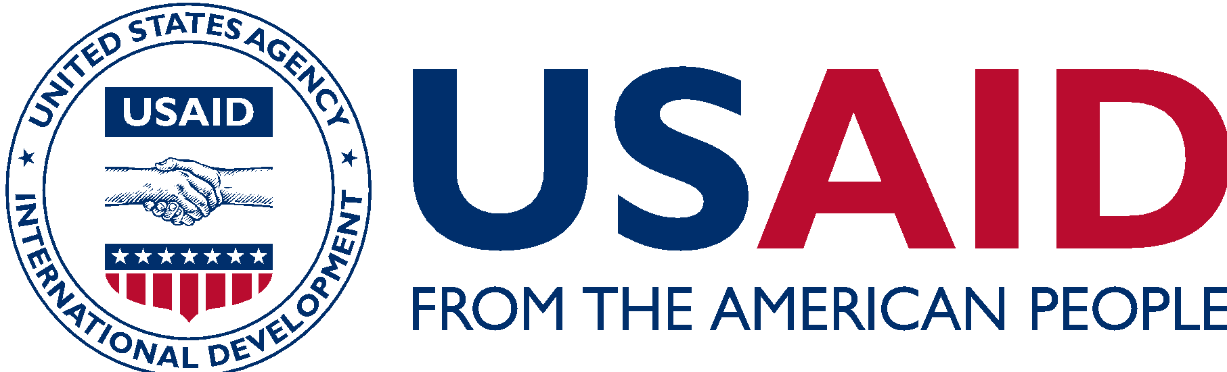
ENHANCING EQUALITY IN ENERGY FOR SOUTHEAST ASIA
USAID is improving gender equality in Southeast Asia’s energy sector to advance women’s economic empowerment and strengthen energy institutions in line with the U.S. government’s Women Global Development and Prosperity Initiative.
Women are underrepresented in the workforce across Southeast Asia, particularly in male-dominated industries like the energy sector. This is more than an issue of equity—it is a missed economic opportunity for countries, companies, and communities. A growing body of evidence links increased gender equality with stronger business outcomes, more innovation, and higher productivity. Tapping into women’s unique contributions can strengthen energy sectors, accelerate inclusive economic and social development, and add trillions of dollars to global GDP.
ADOBE STOCK

POWERING DEVELOPMENT THROUGH GENDER EQUALITY
The three-year activity, Enhancing Equality in Energy for Southeast Asia (EEE for SEA) will expand regional knowledge around gender equality and the energy sector to transform attitudes and remove biases on women in the workforce. EEE for SEA will partner with educational institutions and energy sector employers to attract and retain women through organizational change and leadership development.

IDENTIFY CORE CHALLENGES TO GENDER EQUALITY IN THE ENERGY SECTOR
EEE for SEA will develop a robust evidence base to maximize intended gender equality and social inclusion results in the energy sector.

INCREASE THE NUMBER OF WOMEN AND GIRLS PURSUING ENERGY SECTOR CAREERS
Many girls and young women who would like to pursue careers in the energy sector are either discouraged or simply do not know where to begin. EEE for SEA will increase awareness of energy-related career opportunities. Through EEE for SEA, USAID aims to reverse negative perceptions about women in energy sector jobs and increase internship and mentorship opportunities for women by equipping counterparts with the tools to address unconscious basis.

INCREASE THE RECRUITMENT, RETENTION, AND PROMOTION OF WOMEN
Through EEE for SEA, USAID will coach energy sector employers to change organizational cultures and expand early career opportunities for women. Using best practices, EEE for SEA will partner with employers to implement interventions that help hire, promote, and retain women; to engage men as active drivers of change within their organizations, families, and communities.

INCREASE MENTORSHIP AND LEADERSHIP OPPORTUNITIES FOR WOMEN
EEE for SEA aims to increase mentoring and leadership opportunities with energy sector employers through vocational training and education programs. USAID will partner with energy sector employers to establish and strengthen energy sector centers of excellence and professional networks in the region, and embed programs to ensure sustainability beyond the life of the EEE for SEA project.

ENHANCE COMMUNICATION, COLLABORATION, AND LEARNING
EEE for SEA will strengthen the capacity of organizations, including other USAID programs, to replicate successful gender equality interventions and best practices to foster collaboration.

CONTACT INFORMATION
For more information, please email info-rdma@usaid.gov.

