

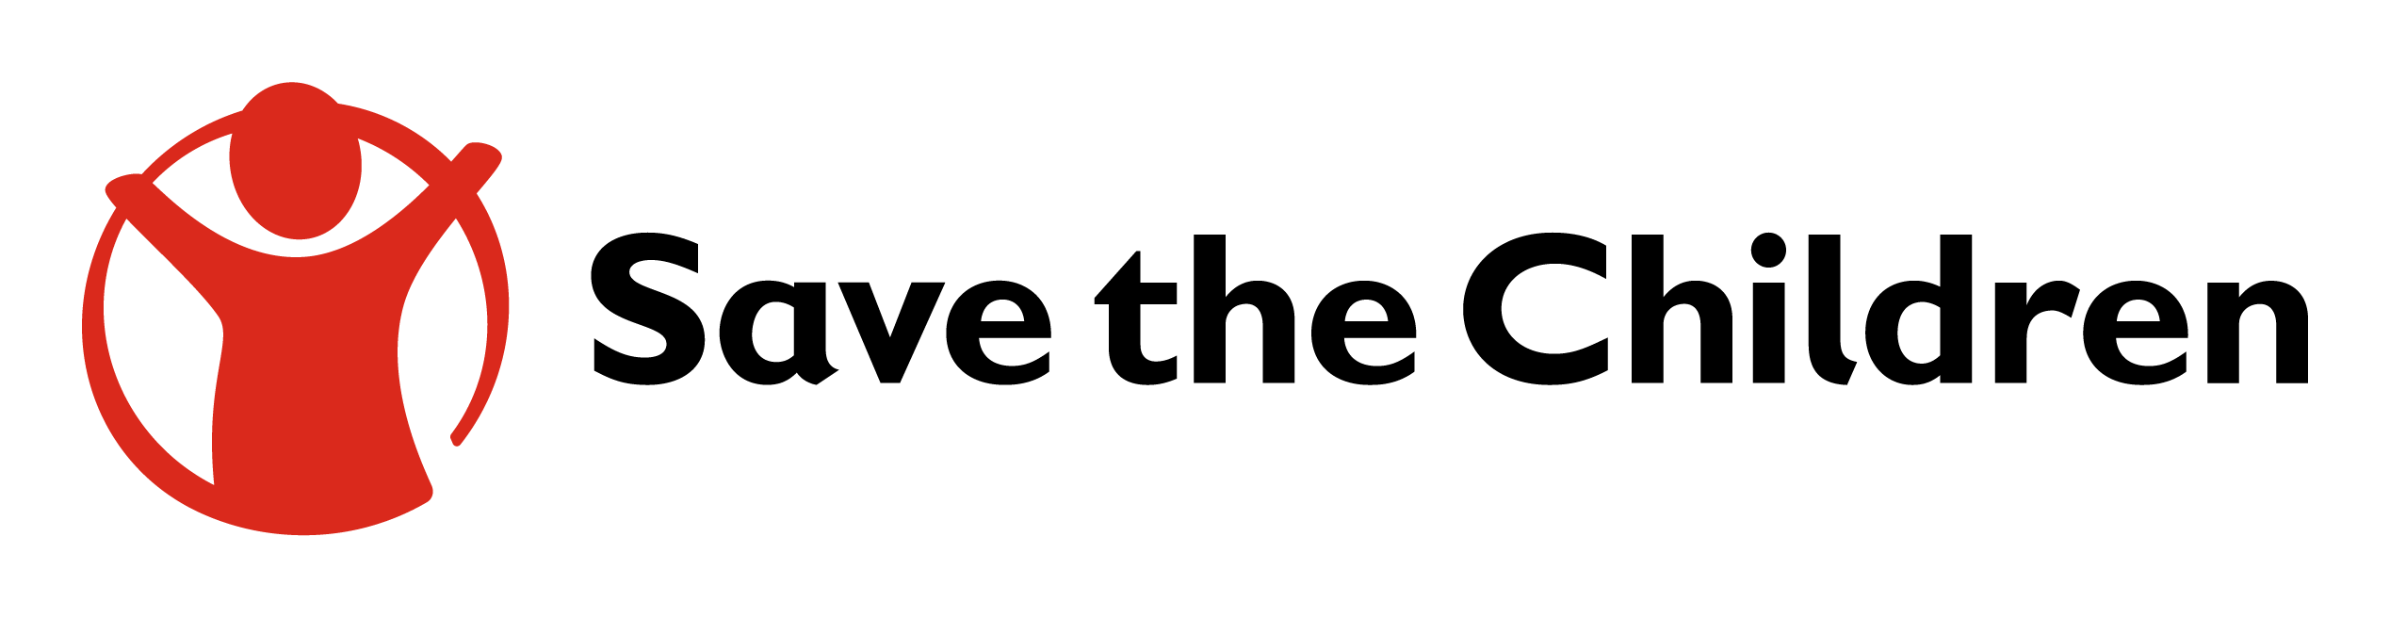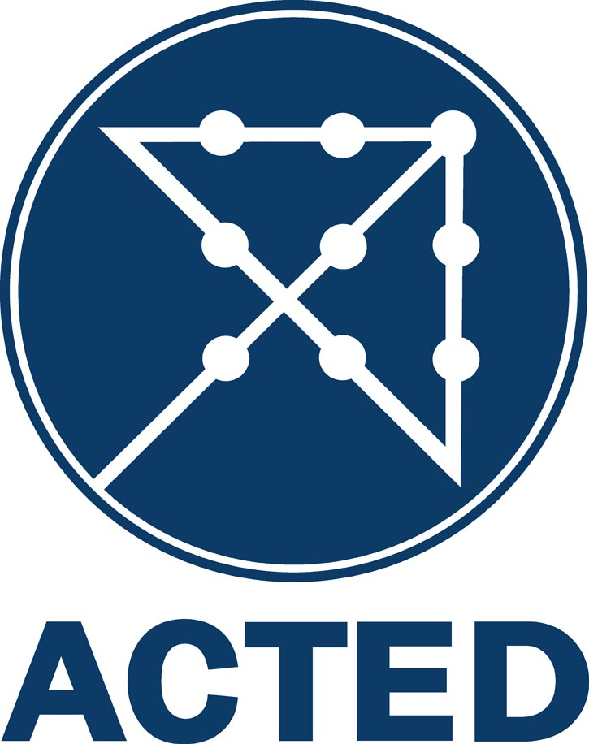

USAID ACHIEVEUSAID Achieve works with local partners to promote cooperation between the public sector, local businesses, and communities to improve economic opportunities for vulnerable youth in three southern border provinces of Thailand. Working in close consultation with the local community and its leaders, the project aims to promote peace and reconciliation by empowering youth from different backgrounds, building their sense of self-worth, and encouraging meaningful engagement with the community. USAID Achieve is part of USAID’S effort to address drivers of conflict and promote participatory and inclusive governance in Thailand in support of the U.S. Government’s Indo-Pacific Transparency Initiative.

# USAID Achieve is guided by the "People to people" (P2P) principle. P2P aims to build trust and cooperation in restoring the relationship between communities through a participatory work process, inclusive of all parties. A common goal among communities in the three southern border provinces is the need to create better economic opportunities for youth. Therefore, USAID Achieve is collaborating with local government agencies, businesses, and organizations that work in economic development and vocational education to better integrate an understanding of cultural sensitivities and special challenges that youth face into outreach programs to prepare them for entry into the workforce.

# Youth as Key actors for peace and reconciliation

Youth empowerment can play an important role in peace building efforts, such as reconciliation, reconstruction, and rehabilitation. USAID Achieve aims to improve livelihood opportunities for young people by equipping them to become productive members of society. The project offers five interactive vocational training programs in: cooking and food preparation, welding, electrical wiring, agriculture, and artisanal craft making. Each program takes 150 hours to complete and covers theory, practices, and entrepreneurial skills training. After graduation, youth are provided with internships and job placement with local employers.

USAID Achieve also focuses on providing counseling, mentorship, and coaching to facilitate reintegration of vulnerable youth to their communities. The project organizes youth camps to provide safe space and the opportunity for youth to dialogue and familiarize themselves with their peers from different backgrounds before beginning vocational training. The youth camp is guided by two principles:

1) The “single identity work” which encourages youth to unpack their reflections on community conflict, their experiences with stigma, and discrimination; and

2) Life skills modules that build the ability of youth to collaborate, resolve conflict, and build respect and empathy for others.

USAID Achieve works with key local community leaders and civil society organizations to promote community collaboration, while simultaneously developing relationships with other stakeholders who have the potential to further support the peace process.

# partnerships for a common cause

Tidarat Thananant / Save the CHildren THailand

USAID Achieve is implemented by Save the Children Thailand, which has academic expertise and project implementation experience in the southern border provinces. Save the Children Thailand also leads a network of local partners, youth communities, and stakeholders in the area together with three other entities: ACTED, which specializes in developing professional vocational training programs; Vocational Institutions (part of the Office of the Vocational Education Commission) in Pattani province, which supports the provision of the vocational training program; and the Steering Committee of USAID Achieve, which consists of representatives from academia, the private sector, civil society, and youth groups. The Steering Committee advises on the local operating context and helps to ensure key stakeholder ownership over the project activities and goals.

**CONTACT INFORMATION**

For more information, please visit www.usaid.gov/asia-regional or info-rdma@usaid.gov.